2025 TERM ONE MZIMBA NORTH DISTRICT EXAMINATIONS
PHYSICS FORM 3
PAPER 1 (100 marks)

Friday, 11th December, 2025
Time Allowed: 2hours
7:30 -9:30am

Instructions

- This paper contains 9 printed pages. Please check.
- Before you begin, write your name and section on top of each paper
- Follow the instructions for each section carefully.
- Write your answers on the question paper in the spaces provided. The maximum number of marks for each answer is indicated against each question.

©MZN-T1-2025
Section A (70 marks) Answer all questions in this section
1. Figure 1 is a diagram showing an illustration of a student eye position when taking a reading of volume of water in a beaker.
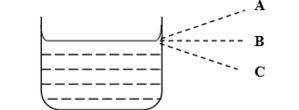
Figure 1
a) Which letter represents an accurate reading level? ___________________________________________________________________ (1 mark)
b) Mention and explain the error likely to be committed in the above diagram during experiment if viewed from wrong lettered position.
___________________________________________________________________ __________________________________________________________________ (2 marks)
c) Calculate the actual value of the liquid in the beaker when the observed value of 11.1 ml gives a relative error of 10%.

(3 marks)
d) List down any two ways of minimising errors during experiment. ___________________________________________________________________ ___________________________________________________________ (2 marks
2 a) Figure 2 is a diagram of a measuring instrument

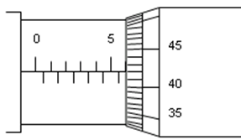
Figure 2
- Name the instrument.
_____________________________________________________________ (1 mark)

- Find the reading as shown by the instrument.

(3 marks)
iii. What type of quantity is obtained when using the above instrument?
___________________________________________________________________ (1 mark)
iv. Mention two advantages of using the instrument above over using a ruler
____________________________________________________________________________________________________________________________________________ (2 marks)
b) Write 0.000065 in scientific notation.
__________________________________________________________________ (2 marks)
c) The hammer strikes the nail and the impact last for 22 milliseconds (ms). What is the duration of the impact in seconds?

(3 marks)
3. Students at Katunguwiri CDSS carried out an experiment to find out if mass affect number of oscillations on a spiral spring. The results obtained during the experiment were recorded as follows;
Mass (g) | 50 | 100 | 150 | 200 | 250
Number of oscillations in 10 seconds | 7 | 9 | 11 | 15 | 19

a) From the experiment above, identify
i. independent variable _________________________________________ (1 mark)
ii. Dependent variable __________________________________________ (1 mark)
ii. Control variable _____________________________________________ (1 mark)
iii. The concluding statement of the experiment ______________________________________________________________________________________________________________________________________________ (2 mark)
b) Plot a graph of mass against number of oscillations use scale of (2cm: 50g) on y-axis and (2cm: 5 oscillations)on x-axis.
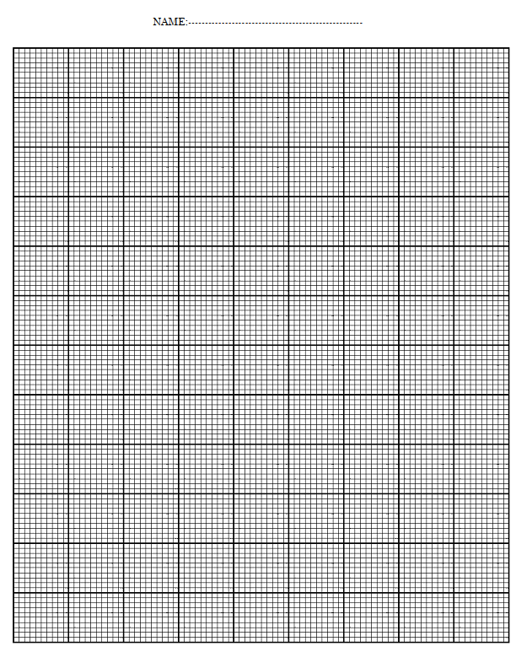 (6 marks)
c) Use your graph to find number of oscillations when the mass is 120 g ___________________________________________________________________ (1 mark)
4. a) Why alcohol in liquid thermometers are preferred in very cold areas than mercury in liquid thermometers. Give two reasons. _____________________________________________________________________________________________________________________________________________ (2 marks)
b) Explain the importance of each of the following features in a liquid in glass thermometer.
i. Constriction _________________________________________________________________________ __________________________________________________________________ (2 mark)
ii. The thin capillary tube with uniform cross-section ____________________________________________________________________________________________________________________________________________ (2 mark)
c) Apart from liquid in glass thermometer name other two types of thermometers
_____________________________________________________________________________________________________________________________________________ (2 marks)
d) Convert 4321 kelvins to degrees Celsius

(3 marks)
e. Figure 3 below shows a type of thermometer
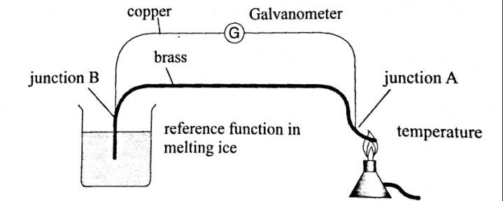
- Name the thermometer shown in the figure above.
___________________________________________________(1 mark)
- Describe how the thermometer in figure 3 measures temperature
____________________________________________________________________________________________________________________________________________________________________________________________________________________________________________________________________________________________________________________________________________________________________________________________________________________________(4 marks)

5. (a) i. State the kinetic theory of matter ____________________________________________________________________________________________________________________________________________________________________________________________ (1mark)
ii. When a candle wax is heated it melts. Explain why this happens.
______________________________________________________________________________________________________________________________________________ (2marks)

b. One student was eating groundnuts at the back of the class, the teacher in front of the classroom soon noticed the smell. Use kinetic theory to explain how this happened. ______________________________________________________________________________________________________________________________________________________________________________________________________________________________________________________________________________________________________________________________________________________________________________ ( 4 marks)
6. a. State the Archimedes principle _______________________________________________________________________________________________________________________________________________ (1mark)
b) Drive the formula to show that pressure in liquids depends on density, height and acceleration due to gravity

(5 marks)
c. Explain two applications of liquid pressure in our everyday life. ___________________________________________________________________________________________________________________________________________________________________________________________________________________________________________________________________________________________________ (4 marks)
d. A hydraulic car jack has a piston of diameter 2 cm and 20 cm. find the weight of a car that can be lifted by a force of 350 N.

(5 marks)
Section B (30 marks)
Answer all questions
7. a) With the aid of a diagram describe how pressure depends on depth

_______________________________________________________________________________________________________________________________________________________________________________________________________________________________________________________________________________________________________________________________________________________________________________________________________________________________________________________________________________________________________________________________________________________________________________________________________________________________________________________________________________________________________________________________________________________________________________________________________________________________________________ (6 marks)
b. Explain two factors which affect pressure in solids ___________________________________________________________________________________________________________________________________________________________________________________________________________________________________________________________________________________________________ (4 marks)
8. Given ice, a source of heat, ruler an uncalibrated mercury thermometer, explain how you can calibrate this thermometer _____________________________________________________________________________________________________________________________________________________________________________________________________________________________________________________________________________________________________________________________________________________________________________________________________________________________________________________________________________________________________________________________________________________________________________________________________________________________________________________________________________________________________________________________________________________________________________________________________________________________________________________________________________________________________________________________________________________________________________________________________________________________________________________________________________________________________________________________________________________________________________________________________________________________________________________________________________________________________________________________________________________________________________________________________________________________________________________________________________________________________________________________________________________________________________________________________________________________________________________________________________________________________________________________________________________________________________________________________________________________________________________________________________________________________________________________________________________________________________________________________________________ (10 mark)
9. Evelyn is investigating the effect of surface area exposed to the air on the rate of cooling of hot water. She designed the apparatus as shown in below
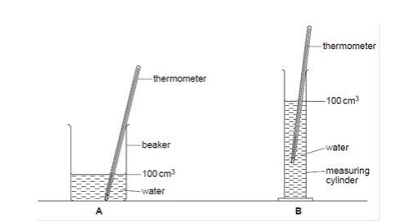

The results were recorded as below
Surface area exposed to air (cm²) | 200 | 300 | 400
Rate of cooling (seconds) | 150 | 100 | 50

Write a lab report indicating aim, materials, procedure and conclusion. ________________________________________________________________________________________________________________________________________________________________________________________________________________________________________________________________________________________________________________________________________________________________________________________________________________________________________________________________________________________________________________________________________________________________________________________________________________________________________________________________________________________________________________________________________________________________________________________________________________________________________________________________________________________________________________________________________________________________________________________________________________________________________________________________________________________________________________________________________________________________________________________________________________________________________________________________________________________________________________________________________________________________________________________________________________________________________________________________________________________________________________________________________________________________________________________________________________________________________________________________________________________________________ (10 marks)

End of question paper!

